**LAB 13**

**Objectives**

To understand the concepts of structures

**Task 1**

Write a C++ that maintain record of students. Student contains following details:

* ID
* Name
* Department
* Email
* Phone no

Create a structure of student. Ask user to enter record for two students. Store those details in variables of students type. Print those records on screen.

#include<iostream>

#include<string>

using namespace std;

struct student

{

int ID;

string name, dept, email, cell;

};

void main()

{

student s1;

cout<<"\t\t\t****STUDENT RECORDS****"<<endl;

cout<<"\n****First Student****"<<endl;

cout<<"Enter ID no : ";

cin>>s1.ID;

cout<<"Enter Name : ";

cin>>s1.name;

cout<<"Enter Department : ";

cin>>s1.dept;

cout<<"Enter E-mail : ";

cin>>s1.email;

cout<<"Enter cell no : ";

cin>>s1.cell;

cout<<"\n****Second Student****"<<endl;

student s2;

cout<<"Enter ID no : ";

cin>>s2.ID;

cout<<"Enter Name : ";

cin>>s2.name;

cout<<"Enter Department : ";

cin>>s2.dept;

cout<<"Enter E-mail : ";

cin>>s2.email;

cout<<"Enter cell no : ";

cin>>s2.cell;

system("cls");

cout<<"\n****Record of first student****"<<endl;

cout<<"\nID : "<<s1.ID<<endl;

cout<<"Name : "<<s1.name<<endl;

cout<<"Dept : "<<s1.dept<<endl;

cout<<"Email : "<<s1.email<<endl;

cout<<"Cell : "<<s1.cell<<endl;

cout<<"\n****Record of Second Student****"<<endl;

cout<<"\nID : "<<s2.ID<<endl;

cout<<"Name : "<<s2.name<<endl;

cout<<"Dept : "<<s2.dept<<endl;

cout<<"Email : "<<s2.email<<endl;

cout<<"Cell : "<<s2.cell<<endl<<"\n";

system("pause");

}

**Task 2**

Create a structure num.Member of structure aretwo integers num1 and num2.Assign values 5 and 6 respectively.Access the member through pointers and print the values.

#include<iostream>

using namespace std;

struct num

{

int num1,num2;

};

int main()

{

num n;

num *ptr;

ptr=&n;

ptr->num1=5;

ptr->num2=6;

cout<<"Num 1 is "<<ptr->num1<<endl;

cout<<"Num 2 is "<<(*ptr).num2<<endl;

system("pause");

return 0;

}

**Task 3**

Write a C++ program that compute Net Salary of Employee. Program contains two user defined functions empSalary() and display().

* Create a structure of Employee that contains following data members: EmployeeNumber, Name, BasicSalary, HouseAllowence, MedicalAllowence,Tax, GrossPay and NetSalary
* empSalary() compute salary with given criteria
  + HouseAllowence = 10% of BasicSalary o Medical Allowence = 5% of Basic Salary o Tax = 4 % of Basic Salary o GrossSalary = Basic+HouseAllowence+MedicalAllowence o NetSalary = GrossSalary – Tax
* display() for displaying details of Empolyee

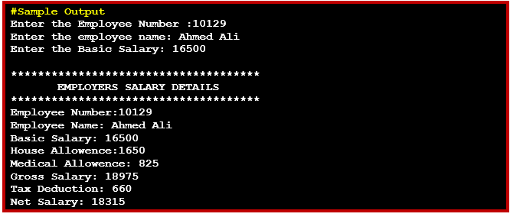

#include<iostream>

#include<string>

using namespace std;

struct employee

{

int empno, bas_sal, h_a, m_a, tax, g_sal, net_sal;

string name;

};

void emp_sal(employee e);

void display(employee e);

void main()

{

employee e;

cout<<"Enter the Employee Number : ";

cin>>e.empno;

cout<<"Enter the Employee Name : ";

cin>>e.name;

cout<<"Enter the Basic Salary : ";

cin>>e.bas_sal;

display(e);

emp_sal(e);

system("pause");

}

void display(employee e)

{

cout<<"\n*****************************************"<<endl;

cout<<"\t\tEMPLOYEE SALARY DETAILS"<<endl;

cout<<"*****************************************"<<endl;

cout<<"Employee Number : "<<e.empno<<endl;

cout<<"Employee Name : "<<e.name<<endl;

cout<<"Basic Salary : "<<e.bas_sal<<endl;

}

void emp_sal(employee e)

{

e.h_a = e.bas_sal * 10 /100;

cout<<"House Allowance : "<<e.h_a<<endl;

e.m_a = e.bas_sal * 5 / 100;

cout<<"Medical Allowance : "<<e.m_a<<endl;

e.g_sal = e.bas_sal + e.h_a + e.m_a;

cout<<"Gross dalary : "<<e.g_sal<<endl;

e.tax = e.bas_sal * 4 /100;

cout<<"Tax Deduction : "<<e.tax<<endl;

e.net_sal = e.g_sal - e.tax;

cout<<"Net Salary : "<<e.net_sal<<endl;

}

**Task4**

Write a C++ program for billing system of MovInPeak restaurant. The program should perform following tasks:

* Show menu to customer for orders.
* Allow the customer to select more than one item from the menu.
* Calculate and print the bill.

Assume that the restaurant offers the following items (the price of each item is shown to the right of the item):

* Omlet $1.45
* French Omlet $2.45
* Muffin $0.99
* French Toast $1.99
* Fruit Basket $2.49
* Cereal $0.69
* Coffee $0.75
* Tea $0.50

Notes:

Define a struct MovinPeakMenu that contains following data members.

* menuItem [ ] of type string
* menuPrice [ ] of type double

Your program must contain following functions:

* Function getData: This function store the food items into the array menuList.
* Function showMenu: This function shows the different items offered by the restaurant and tells the user how to select the items.
* Function printCheck: This function calculates and prints the check.

(Note that the billing amount should include a 5% tax.)

